# Project Doubt

Question to ask

1. System design document or architecture document?

2. How the system will work?

3. KT about the demo?

4. Software and which document I should follow?

1. Who is the end user?

OCC team will do key in data,

1. know more about Work Order, technical alarms, environmental monitoring list

My work is to create Demo software for ITSWC 2019 deliver on August

1. What software I have to use for demo. All the feature need to cover, is any other person involve in this demo.
2. The other person develops the UI design. (Software detail)
3. I want to know in which module I have to start first.
4. So I get the data from DB or other source and display in GIS monitor, CC, BIS.

OWA workstation simulation workstation

1. Also concentrate on planned event (Mobile IR) and unplanned event (accident IR)

So far I understand get the Data from the db and display into 3 different panels.

I need for data. (Where to store and retrieve the data) – (Do I create DB table if yes I need table design)

Incident Record

Work order

Technical Alarms

Environmental Monitoring list

How to send data to the client. It’s a JSON object or any other

BIs real time – which data is used for different chart 1.

Doubt

In Incident record display lane column what condition apply to choose the colors. RED, GREEN

# Employee Department

|  |  |
| --- | --- |
| **Person** | **Name** |
| Employee ID | E523 |
| Department | DPB854 |
| Project Name | TT231 - Upgrading of i-transport system |
| Building Access ID | T1586 |
| Official Email | [manjula.devadoss@ext.soprasteria.com](mailto:manjula.devadoss@ext.soprasteria.com) |
| Hrms – Leave apply | <https://ssa-ehr.steria.com.sg/Web/Login.aspx>  Emplid /  |
| Web Email | <https://outlook.office365.com/mail> |
| Onedrive | https://steria-my.sharepoint.com/personal/manjula_devadoss_ext_soprasteria_com/_layouts/15/onedrive.aspx |
| Onenote |  |
| Share point folder | https://steria.sharepoint.com/_layouts/15/sharepoint.aspx |
| Hithub Repository | Github Desktop and url added  [Logi](mailto:Manjula.devadoss@ext.soprasteria.com)n SopraId /  |

|  |  |
| --- | --- |
| **Person** | **Name** |
| Aaron | - UI designer |
| Tian he | - Technical Consultant |
| Oscar | - Project Manager |
| Cos module | - workflow of the system  - Operational system PT_COS |
|  |  |
| Live website | https://www.onemotoring.com.sg/content/onemotoring/home.html |

1. Email to Tian He to get more technical design
2. Concentra on IR – Incident Record –
   1. Planned event (Mobile IR)
   2. No Planned event (Accident)

# Folder Access

**Project Folder**

1.)    \\10.180.8.9\Projects\Singapore\Transport\Road\ITS\TT231\

2.)    \\10.180.8.9\Projects\Singapore\Transport\Road\ITS\RP147

I think accessing TT231 project folder should be benefitial for you to work on the preparation for ITSWC.

You may find the project design related folder @\\10.180.8.9\Projects\Singapore\Transport\Road\ITS\TT231\PDF - Product Files\01 - Project Design.

For existing TT231 storyboards works, they can be found in\\10.180.8.9\Projects\Singapore\Transport\Road\ITS\TT231\PDF - Product Files\01 - Project Design\07 - User Interface Design Document\Storyboard

As TT231 is still under design phase, you may refer some old system features by studying the old system manuals \\10.180.8.9\Projects\Singapore\Transport\Road\ITS\RP147\PDF - Product files\1 - i-transport\25 - Detail Design Documents, Maintenance Manual and Training Manual\20190131_Submission\Integrated  Workstation Manual

**Leave Apply Link**

# Laptop configuration

Widnows 7 Professional

6:GB RAM

64 bit OS

Need todo: Configure outlook

# Useful Links

|  |  |
| --- | --- |
| JVM | <https://blog.overops.com/jvm-architecture-101-get-to-know-your-virtual-machine/> |
| Bootstrap setup | <https://www.codecademy.com/articles/bootstrap>  ----- Bootstrap setup -----  1. Add boostrap folder into your project (dist Folder)  2. Boostrap dist folder, it contains css, js files  3. Change html file "src and link location " in to copied file location |
| jquery and bootstrap links or chart | https://mdbootstrap.com/snippets/jquery/temp/373176?action=prism_export  https://canvasjs.com/jquery-charts/pie-chart/ |
| MAP | <https://www.amcharts.com/javascript-maps/> |
| Google Chart | <https://www.w3schools.com/howto/howto_google_charts.asp>  Examples Files  <script type="text/javascript" src="https://www.gstatic.com/charts/loader.js"></script>  Files : piechart1.html  File : pie1.js |
| Grid | <https://www.w3schools.com/howto/howto_js_list_grid_view.asp>  Examples Files  <script type="text/javascript" src="https://www.gstatic.com/charts/loader.js"></script>  Files : gridexp.html  File : pie1.js  File : colchart.js |
| Color Key | "#CDA776",  "#989898",  "#CB252B",  "#E39371",  "#1D7A46"  "#DEB887",  "#A9A9A9",  "#DC143C",  "#F4A460",  "#2E8B57"  “A9A9A9” – gray |
|  |  |

# Software Installation

1. jdk1.8.0_201
2. Eclipse IDE for Java Developers (Nano) neon 03
3. apache-tomcat-9.0.16
4. apache-maven-3.6.0
5. Giphub Desktop - <https://desktop.github.com/>
6. Bootstrap / Note js / Angular Js

## Copy Files

C:\Users\mdevadoss\workspace

C:\documents\github

# More Detail

## Question to IT-Help Desk

I couldn't access Share point folder - let say access one drive, one note etc.,

I couldn't configure my outlook. - currently using browser to view email

The wifi is disconnecting Frequently

Understand and Practice

* Json file creation
* Panel Display
* war file creation

Get icon from UI developer

user type - display screen --

Menu(IR) and operation

Identify the screen list

Approach for demo:

1. Identify all screens. Title of the screen, one line description, used by, what can they do with that?

2. Create a spreadsheet with above information and tag them with UI storyboard section

3. Write an email to whoever and tell them:

- Create key screens using HTML5/Bootstrap/AngularJS/JSON technologies on a normal white background theme

- Internal Demo them as phase 1 to Manager and UI person

- After demo, receive feedback. Proceed to either implement more screens or

develop backend logic with database for the existing screens

- Give more internal demo and receive feedback.

- Incorporate the feedback in spreadsheet and work on it

BIS I need help.

I want sample data.

# LTA Project Notes referred from storyboard document.

## Deliver on

Project TT231 I-Transport version 2.0

Oct 2019 - Deliver on to ITSWC 2019

August 2019 - LTA demo

Upgrading i – transporting System

The document all about to interaction between user and i- transport

**OWA Frontend Interface**

## Abbreviation

|  |  |
| --- | --- |
| GIS | Graphics Information System |
| BIS | Business Intelligence |
| IR | Incident Record |
| CC | Common Control |
| PMCS | Power Management Control System (or) Plan monitoring control system |
| VMS | Visual message system |

User has the options to create, edit and manipulate these records like Incident Records, work order, technical alarm, and Environmental monitoring list

Panel displays

* PMCS measuring alarms,
* TTD threshold warnings
* Fire alarms
* Accident
* Road Works
* Breakdowns
* Mobile Road Work
* Obstacle
* Heavy Traffic
* Road block
* Unattended vehicle
* Miscellaneous

**Common Control System**

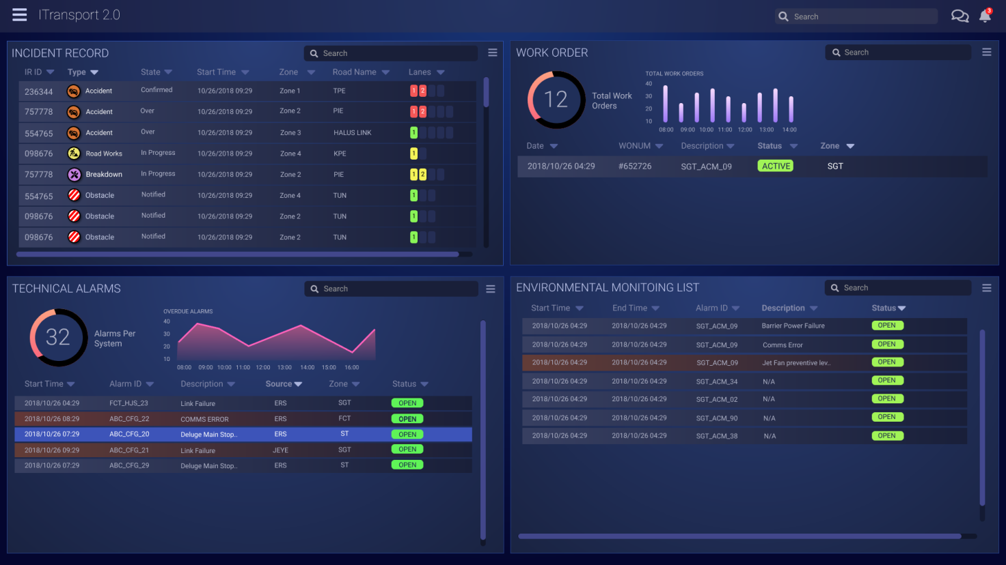

**Events**

Events panel shows all available planned events.

1. Today and 2.Upcoming events like Asia Summit, ABBA Concert etc.,

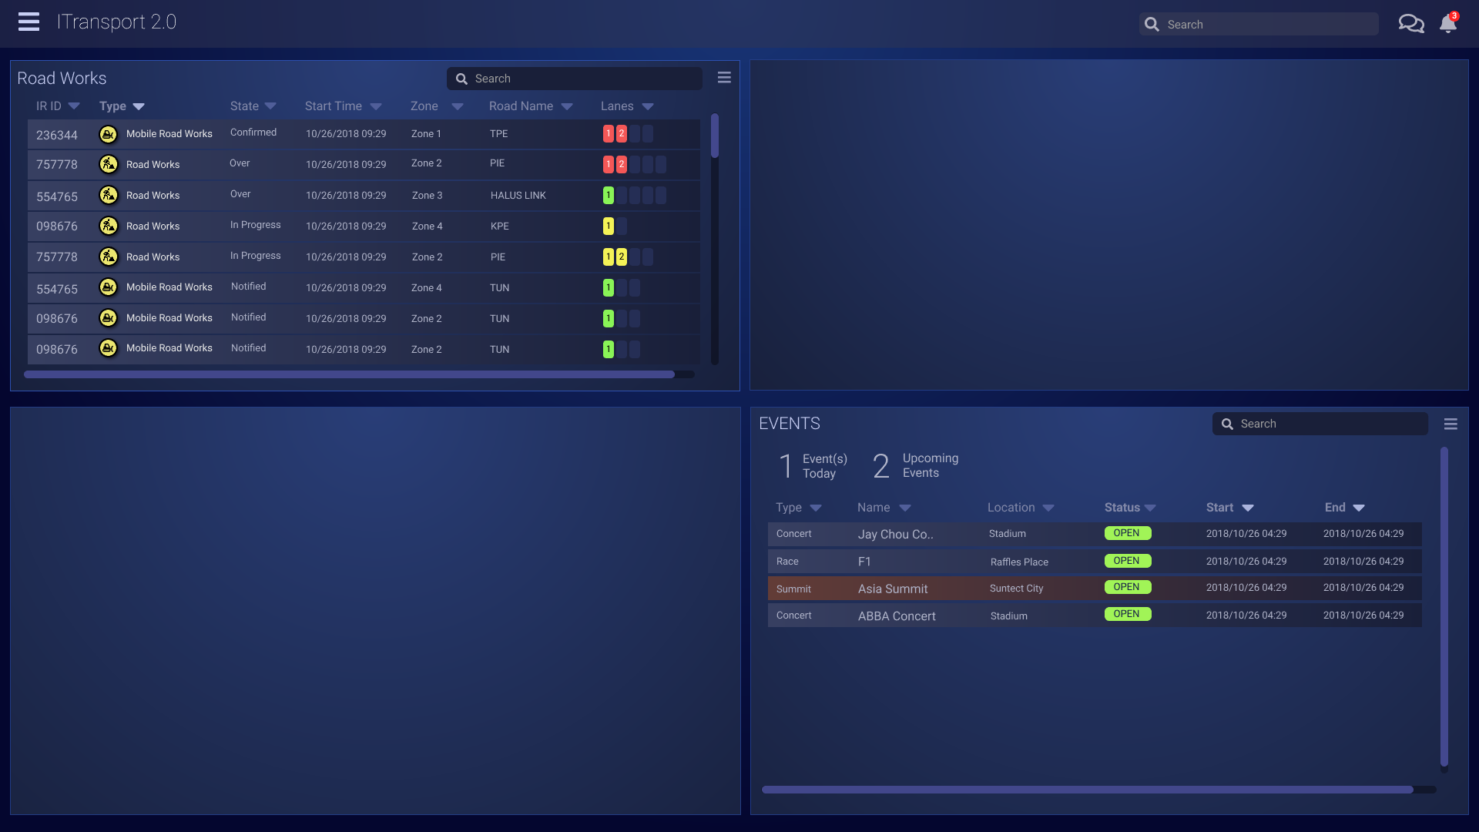

GIS (Graphics Information System) Map shows important event on interactive Map

GIS MAP

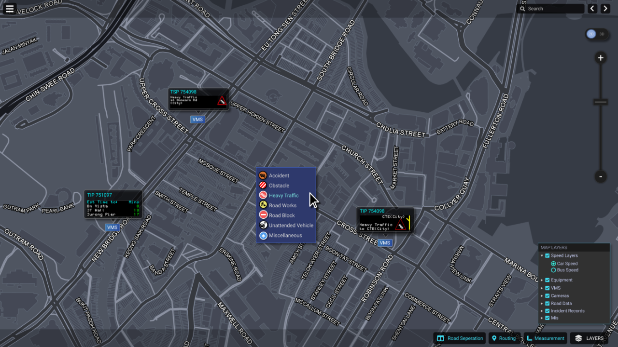

**BIS Real time**

* BIS (Business Intelligence) Real time page displays
* Real time static of live traffic data.
* Customizable with a variety of different charts and statistics

BIS Real time screen

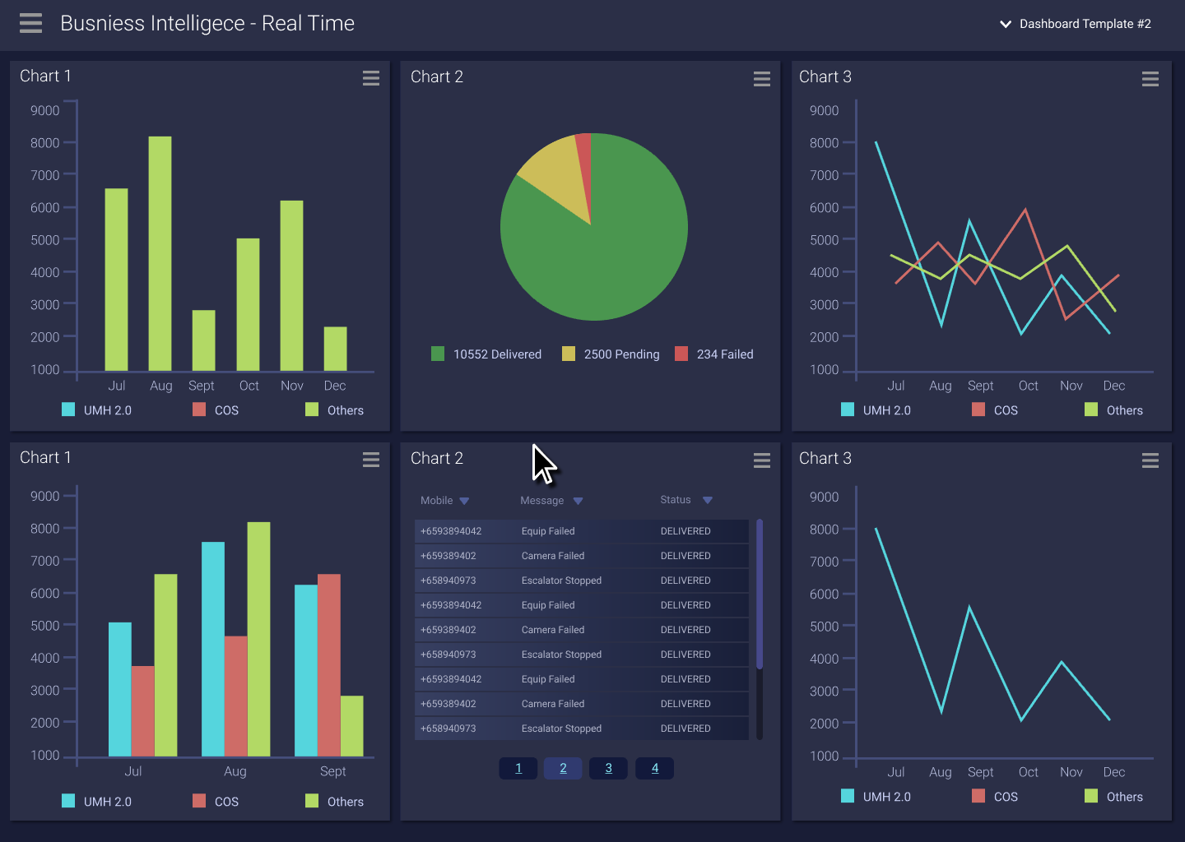

OWA User login

1. Enter user name and password
2. Select Zone Selection
3. Successful user get OWA interface with 3 window GIS, CC, BIS
4. **Common Control System (CC)**

Four Panels will display

1. Panel filtering like sort the zone

2. Merge two panels

3. Split the panel

4. New Technical alarm notification

1. Business Intelligence System (BIS)

* Displays real-time analytics of road conditions
* Other system information
* Customizable chart by the user and saved
* Each panel can be set to a specific chart

1. Incident Record (IR)

* GIS map to reveal a dropdown list of all available IR’s.
* User can create and edit the IR settings like heavy traffic
* To block or unblock the lane.
* To add/delete new lane
* VMS Message - user can multi select the VMS plans
* OBU message
* Record and track all assets on the ground. can type vehicle number display on the map
  1. MRT breakdown IR workflow
* Create MRT Breakdown IF - enter breakdown line
* Enter more detail about breakdown
* Create heavy traffic IR
  1. Mobile Roadwork
* Create a Mobile work
* can able to track the vehicle
  1. Equipment Control Workflow
* Equipment control popup
* EMAS, Monitor, Junction, FCT
* FCT - VMS, Camera, LUS, Jet Fan, Lighting, RBBI
* The Quick Equipment control has 4 main sections, Manual, IR & Events, Time Config & Default Message
  1. Single Equipment Control
  2. Event Workflow
* Ongoing and upcoming event
* User can create the new Event and lane detail
* Add VMS plan
* Two Status : Planned / Approved
* After approving to be implemented
* On event date status as "Live"
  1. Miscellaneous Tools
* Deleting An Event
* Critical junction tool
* VMS Library
* VMS side menu
* VMs Gallery
* VMS Editor
* Pictogram

Incident Type---

Accident

Vehicle Breakdown

Unattended Vehicle

Road Works

Obstacles

Slow Trafiic

Weather

Road Block

Miscellaneous

Diversion

fire

Plant Failure

Reverse Flow

Zone---

Zone 1

Zone 2

Zone 3

Zone 4

Zone 5

CTE Tunnel

FCT

Notification ----

Vehicle Recovery System

LTA Traffic Marshal

EMAS ----

Ventilation

Aircon

Lighting

Drainage

Door & Staircase

Power

Fire Alarm

Call in Alarm

**Key Notes**

1. Login
2. User can view 3 panel display
3. User Create Incident Record (IR) from GIS Panel
   1. Incident Record (Heavy Traffic) saved automatically
   2. Based on the IR to block or unblock the lane. (can create/edit/delete new lane)
   3. Can configure VMS plans, Canning messages, OBU messages, Congestion Routes, Partners & Vehicle Response
   4. User can add more VMS message using ”Add to Plan ” option also you can select multiple vms message
   5. This VMS message display on the GIS Map panel
   6. Implemented and failed status for VMS message. If the status is failed the VMS message send to work order
   7. User can also configure OBU message - 3 regions are identified. Alert, Jam & Guide.

Partners & Vehicle Response allows users to record and track all assets on the ground. Type the vehicle for future track.

1. User Create MRT Breakdown (IR) from GIS Pane
   1. MRT line, start time, end time, alarm, alert, status etc
2. Mobile roadworks IR
   1. Tomorrow …….

**History**

Every user authorized to use Platform Control Mode (PCM) or Fall back Control Mode (FCM).

Authorized Users

Operator

FC

Supervisor

DO

ITSC

Operation Mode

PCM (Platform Control Mode)

FCM (Fall back Control Mode )

Types of records available:

•       Past traffic alerts

•       Past technical alarms

•       Past reading alarms

•        History of operator commands

•       Past incident records

•       Past equipment status

      •       Past work order records

Features:

•      Search and retrieve historical data.

•       Filter the historical data.

•      View GIS for the historical data.

1. Filter by Source

(All, i-transport AID, EMAS AID, SOS phone etc)

1. Filter by Zone

(Zone 1,2... All)

1. Past traffic alerts

**Start Date/Time** – “From and To” -**Search**

3. View GIS

2. Search historical traffic alerts

1. Filter the List

1. Filter the List

1. Filter by Source

2. Filter by Zone

3. Equipment – (EMAS, JEYE, GUDE)

4. Tech Alarm Start DATE/Time

2. Past technical alarms

2. Search historical technical alarms

**Start Date/Time** – “From and To” -**Search**

3. View GIS

3. Reading alarms

**Start Date/Time** – “From and To” -**Search**

3. View GIS

2. Search historical technical alarms

1. Filter the List

1. Equipment – (EMAS, JEYE, GUDE)

1. User ID

2. Command Types (Manual Control, IR Handling, Activate IP etc)

3. **Start Date/Time** – “From and To” -**Search**

1. Search Historical Operator Commands

4. Operator Command Log

2. Operator Commands types

Manual Control commands

• Manual equipment control commands etc.

5. Incident Record

2. Search by historical Incident Record

1. Filter the List

1. Incident Type

2. Notification

3. Zone

1. Search By : Time, IRID, Vehicle Number

2. Start Date/Time Form and To

3. View CCTV, Prioritising and Editing Incident Records

1. CCTV Function

2. Edit Function

3. Priority Function

6. Equipment Status

1. Search Historical Equipment status

1. Start Date/Time Form and To

2. View GIS

1. Start Date/Time Form and To

Filter by Fault Source (EMAS, GLIDE, FCT)

2. Search historical work order

1. Filter the List

7. Work Order

## Screen Design Links

Popup window use it for IR creation

https://www.w3schools.com/howto/tryit.asp?filename=tryhow_js_popup_form

<https://www.w3schools.com/howto/tryit.asp?filename=tryhow_js_popup_form>

Hover Tabs

https://www.w3schools.com/howto/howto_js_hover_tabs.asp

**Menu Icons**

<https://www.w3schools.com/howto/howto_css_menu_icon.asp>

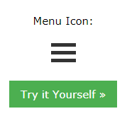

**Image setup syntax**

<img src="img_girl.jpg" alt="Girl in” style="width:500px;height:600px;">

<img src="img_girl.jpg" alt="Girl in a jacket" width="500" height="600">

**Drop down Menu**

<https://www.w3schools.com/howto/howto_css_dropdown_navbar.asp>

**Ng-hide and ng-disabled in Angular**

</head>

<body ng-app="">

<label>Click me to toggle: <input type="checkbox" ng-model="checked"></label><br/>

<button ng-model="button" ng-disabled="checked">Button</button>

Hide: <input type="checkbox" ng-model="checked" aria-label="Toggle ngHide"><br />

<div class="check-element animate-show-hide" ng-hide="checked">

I hide when your checkbox is checked.

</div>

</body>

</html>

**Right Click Menu**

<https://jsfiddle.net/djibe89/qej2ppcq/>

**Modal – popup window anguarl js**

<https://embed.plnkr.co/plunk/PbnBdN>

**Modal – popup window bootstrap**

<https://getbootstrap.com/docs/4.0/components/modal/>

**Angular sample example**

<https://docs.angularjs.org/guide/forms>

**Font Colors and name of the colors**

https://www.w3schools.com/cssref/css_colors.asp